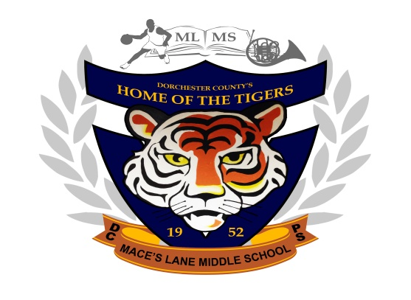
Mace’s Lane Middle School
at the Edythe M. Jolley Educational Center Campus
1101 Mace’s Lane
Cambridge, MD 21613
Phone: 410-228-2111 Fax: 410- 221-5278

Michael W. Collins, Ed.D.
Principal

Grade 6 Grade 7 Grade 8
Cynitha Woolford Robin Mackert Adam Tolley
Assistant Principal Assistant Principal Assistant Principal
Deborah Wooden Jordan Fitzgerald Roland Finger
School Counselor School Counselor School Counselor

October 13, 2016

Dear Parents/Guardians,

We are excited to introduce a new way for you to access classroom assignments and homework for our students when they are absent from school. The site is called Weebly, and it is a way for use to place student work online, so that it can be downloaded and completed while students are away from school. It is easy to access and use, so that students can complete work that they miss while they are absent as well as catch up on any assignment that you see is missing when you check PowerSchool.
To visit the site, go to http://mlmsdcps7.weebly.com/ on any internet connected computer or tablet. (If you are viewing this letter online, hold down the Ctrl key and click on the link. Once there, you can click on any of the tabs at the top of the screen to access assignments from your child’s classes.
Click on the teacher’s name to email them.
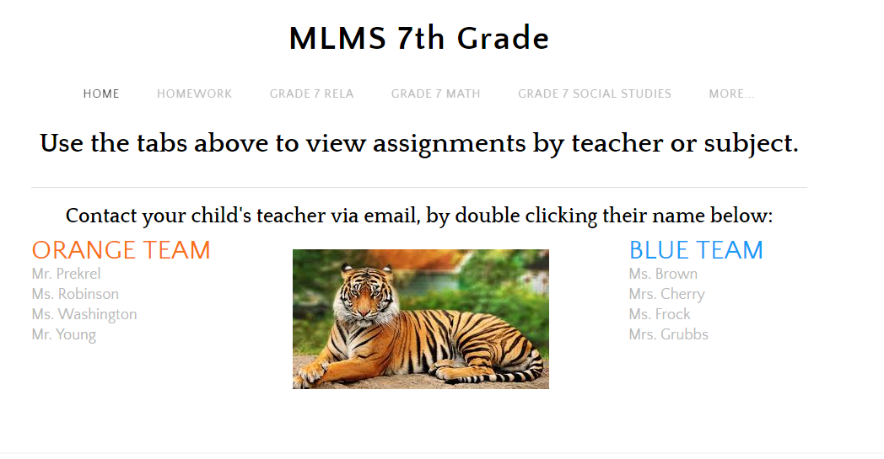
Click on the tabs on the top. top!
Once on the page, you can click on assignments to download them. They can be printed out if you have access to a printer, or your child could complete them on loose leaf paper to turn in when they return to school.

Click on Download File to open the assignment!
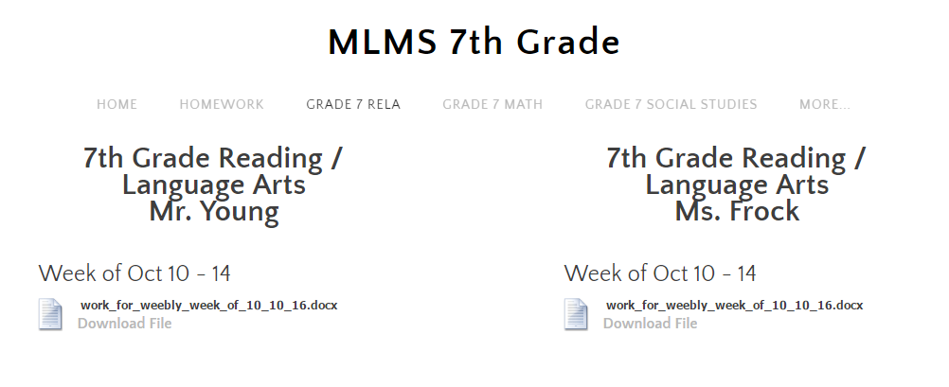

All of the files have been saved so that you don’t need a specific program to open them. You may want to update to the newest version of Adobe Reader (it’s free and your computer should already have it installed).
You can also email any assignment that has been completed directly to your child’s teacher. All of our email addresses are linked to the home page of Weebly.
We have also included some helpful links to websites that can help you help your child complete the assignments. Khan Academy is a website for math or science related concepts that has videos that show step by step directions for math problems – just type in the category or type of problem that is included in the assignment and videos should be available for anything we work on in seventh grade. Flocabulary is a great way to help students learn reading concepts in a fun way. They are all hip hop songs! The best way to do this is YouTube. Simply search Flocabulary + the name of the concept that is being worked on.
Please don’t hesitate to contact Mr. Young, younge@dcpsmd.org, at the school if you need help accessing these websites. We hope that this will be another helpful way for us to communicate and improve the success of our students here at Mace’s Lane Middle School.

Sincerely,

The Seventh Grade Team
Mace’s Lane Middle School

